
SYSTEMS DIVISION
IPD Application Architecture

DRAFT
03/07/06

Prepared By:

Donna Hernandez
Larry Lazzarini
Jed Cotton
Ayyamani Sadasivam

File Name:
Document  Reference: | IPD Application Architecture
Version: | Version 1.0
Status: | Draft
Sign-off
Authorized by
Brad Samuels
Contents

1. Introduction 6
1.1 Business Drivers 6
1.2 Overview 6
2. Use Case View 7
2.1 User Logon 7
2.2 Please specify all use cases similar to Logon 8
3 Logical View 9
3.1 Logical Packages 11
3.1.1 Presentation Services Package 11
3.1.2 Application Services Package 11
3.1.3 Business Services 12
3.1.4 External Integration Services 12
3.1.5 Infrastructure Services 13
3.1.6 Batch Processes 13
3.2 Processing Paradigm 14
3.2.1 Foundation Framework 14
3.2.2 Batch 14
3.2.3 JGRINDER/JDBC 14
3.2.4 Oracle Packages 14
3.3 User Interfaces 14
4 Process View 15
4.1 Operator/User/Help Desk/Product Maintenance Workstation 15
4.2 TPF Adapter Server 16
4.3 IPD Server 17
5 Deployment View 18
5.1 Process Deployment 18
5.2 Processing Needs (Application Layer) 19
5.2.1 Hardware 19
5.2.2 Performance 19
5.2.3 Availability/Reliability 19
5.3 Data Needs (Information Layer) 20
5.3.1 Physical Location 20
5.3.2 Capacity 20
5.3.3 Integrity 20
5.3.4 Access 20
5.3.5 Management 20
5.4 Hardware Installation 20
5.5 Third-Party Products 21
5.6 Software Installations 21
5.7 Maintenance 21

Foreword

The application architecture is a blueprint for what the developers will build. Like a building blueprint, it outlines the major features both physical and functional. It details the type of hardware, if not the specific hardware. It outlines the dimensions of the architecture by specifying the boundaries. It builds-in any required security, capacity, performance, maintenance, and operational needs. It specifies all external and user interfaces to the application. The application architecture is the vision for what the built system should look like. Although the architecture may change slightly over time, it gives the designers and developers a view of what the final product should be.

Scope

The application architecture covers the high level view of the final system. It will provide the vision for other more detailed documents. It will cover both the logical, physical and functional aspects of the application. Although the application architecture is not enough for a developer to begin building the application, it is necessary for providing a common vision and determining synchronization points for multiple teams.

Audience

The system owner should read this document to ensure it captures the owner’s vision for functionality and presentation. The system architect should read this document to ensure it adheres to the enterprise architectural vision and philosophy. The information architect should read this document to ensure it properly captures the business functionality. The infrastructure architect should read the document to ensure that the application uses the infrastructure items wherever possible. The technology architect should read this document to ensure the application properly uses the appropriate technologies. The system engineer should read this document to understand the vision and constraints placed on the system. The system engineer will reference this document when building the system requirements and performing system analysis. The designer should read this document to ensure his design captures the architect’s intent. The developer should read this document to ensure the implementation realizes the architect’s vision of the application.

Prerequisites

Readers should be familiar with the system architecture, the information architecture, the infrastructure architecture, and the technology architecture for this project.

Organization

- The Introduction section contains background information, the business driver force and the technical driver force for the system, and an overview of the system context.
- The Use Case View section provides the motive and describes the system needs in concrete terms.
- The Logical View section describes the static and dynamic aspect of the system in terms of packages, subsystems, components, and their responsibilities.
- The Process View section represents the decomposition of components in terms of execution flows. Process View also represents the synchronization between the components and the availability and reliability of them at the process level.
- The Deployment View section describes how the processes are deployed at the processor level. It discusses the scalability and fault tolerance features of the system. The hardware and software tools are also documented here.

Introduction

This document addresses the application architecture of the IPD application that is used primarily by the “Window” users to send all product and series information to the Trading Floor applications (CBOE Direct, TPF and PDS).

Business Drivers

IPD is developed to centralize all industry product and series information into one central source of information, instead of the data being sourced in from different applications. IPD will provide all product and series information on an intra day and end of day basis.

Overview

IPD will provide a simplified mechanism to add new classes and series both intra-day and end-of-day. IPD will also provide an automated method of notifying all the affected parties.

Use Case View

User Logon

Use Case Name | User Logon
Actor | Regulatory ?? Group
Pre-conditions /Assumptions | User has Internet explorer and is aware of the http path to the application
Post conditions

Flow of Events | - The user will submit the User-ID and password  - A login request is sent to the system with user ID and password and is validated with the server  System will send a success message on successful message
Alternative Paths | If the user submits an invalid user id or password in the system, the system will validate and send an “invalid login” message to the user  If the system is down and the validation could not be performed then the system will send a “System down, contact systems support” message to the user
Frequency | - ?? users
Notes: | If the user does not remember the user id/Password they should contact the administrator (ICT) to retrieve their information
Performance Requirements

Data Access Scenarios | Tables and Access Path | Percent Rows Retrieved | Average Frequency
No tables will be used | Security Service will be used to authenticate user ID and password

Please specify all use cases similar to Logon

Each use case can represent a functionality. Usually we have only done use cases for the GUI as the batch will be represented further below. Refer to ITA Application Architecture on the intranet to get a better picture.

Use Case Name

Actor | Regulatory ?? Group
Pre-conditions /Assumptions | User has Internet explorer and is aware of the http path to the application
Post conditions

Flow of Events

Alternative Paths

Frequency

Notes:

Performance Requirements

Data Access Scenarios | Tables and Access Path | Percent Rows Retrieved | Average Frequency

Logical View

The Logical view of this system is presented below

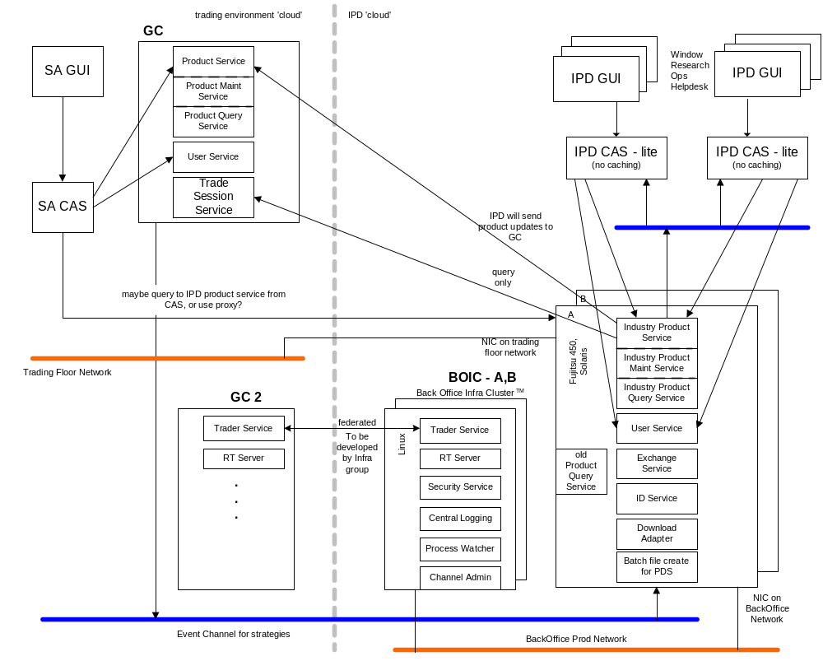

The IPD Application will be comprised of the following five logical packages of functionality
- Presentation Services (IPDGUI)
- Application Services (Client Application Server (IPDCAS))
- Business Services (IPD Server)
- External Integration Services
- Infrastructure Services
- Batch Process

The Presentation Services (IPDGUI) provides a GUI to enable the users to interact directly with the system and is based on SBT’s SAGUI.

The Application Services package contains subordinate packages that forward requests initiated by human or automated actors, to be executed by the appropriate Business Services package(s).

The Business Services package contains the core functionality of the IPD system. It includes components that correspond to the key business object model entities of IPD such as the product query service, product maintenance service et cetera. In addition, it includes components to administer and operate the IPD system

The External Integration Services package consists of adapters that map the interaction paradigms of external systems to the ones in the IPD system architecture. For now, TPF and SBT are the only external systems.

The Infrastructure Services package contains Commercial Off-the-Shelf Software (COSS) and extended infrastructure services that provide enterprise-wide support to CBOE systems

The batch processes include interfacing to the Data Warehouse tables as well as generating reports for the OCC.

Logical Packages

Presentation Services Package

The Client Services contains the IPD GUI package.

IPD GUI

The IPD GUI display is based on the model-view controller pattern. The IPD GUI Display is responsible for displaying the contents of a particular model to the screen and updating the display if the model’s contents change.

A GUI framework is implemented here to promote the consistency in look and feel and speed up the GUI development work

Models

Certain models including product class, reporting class and product are singletons within a distinct GUI application and thus will be shared among multiple frames and panels. For the purpose of speed of display, each market data display panel/frame has its own copy of a market data model and underlying model for those products in which a particular frame is interested.

Application Services Package

The Application Services package contains an application for each human actor in SBT. These applications submit requests to Business Services components, notify clients of business events, and maintain user-specific views of information in the Business Services. CBOE has chosen to support a robust, full function API using the CORBA/IIOP protocol. The API’s functionality will be exposed as a set of CORBA IDL interfaces to facilitate its use from any language with a CORBA mapping

To simplify application development and maximize performance, the API will be multi-threaded and thread-safe. Also, the API exposes the public interface of the underlying application (i.e., Industry Product Query Service, Industry Product Maintenance Service etc.)

IndustryProductUserAccess

The User Access service provides for authenticated login to the Application Server. The User Access service is the first and last service accessed by an application. The logon method returns a reference to the API Manager service - which provides access to the application server services

IndustryProductQueryService

The Industry Product Query service provides for the retrieval of product information.

IndustryProductMaintenanceService

The Industry Product Maintenance Service provides for maintenance of class and product information.

Business Services

Industry Product Query Service

The Product Query Service allows user to retrieve product and class related information from IPD.

Industry Product Maintenance Service

The Product Maintenance Service enables users to add new classes and products as well as to edit existing entries.

Industry Product Resync Service **now ar command*** under ipms

The Resync Service is used to resync data between IPD, SBT and TPF. For now, this service is only informative; it lists out the differences between the three systems but is not automated to synchronize the systems; user intervention is still necessary to sync up the systems

Industry Product Status Service

The status service is used to retrieve statuses from IPD as with regards to transmits to SBT and TPF. This service will enable users to obtain statuses of products and classes which were sent to TPF and SBT.

External Integration Services

The External Integration Services package contains subordinate packages implementing the Adapter Pattern that “adapt” (or “wrap”) the native legacy interfaces to interfaces appropriate in the IPD environment.

TPF Adapter

This package contains the adapter to allow IPD and TPF to interact. TPF data is received, repackaged, and broadcast/delivered to the appropriate components within IPD. Conversely, IPD data is received, either through direct invocation or event consumption, repackaged, and sent to TPF using its native interface

The TPF Adapter handles product related flows; IPD notifies TPF of intra-day events affecting products such as new series added, stock splits, et cetera.

Infrastructure Services

Overall there are four major tiers of the application that can be identified. The business services handle the entire IPD product and series related functionality. It provides the repository for all IPD information data. The application services handle the application presentation and act as the application front end to the business services. Different views of the business services and collaboration of business objects are grouped together and are presented to the user based on logon authentication and authorization level. The two tiers communicate to each other by two supported tiers: the infrastructure services and external integration services. The infrastructure services take care of the plumbing underneath to provide a seamless integration between the application services and business services. The external integration services provide the access to the external system.

Most of the common services are grouped together inside the Infrastructure Services. The services are defined when possible using standard service specification (CORBA services) and technology engines to minimize the cost of development and deployment. At the same time, this approach also ensures the openness of the application architecture without locking the architecture into any one vendor product and technology.

Since the infrastructure services are similar to those of SBT, please refer to SBT Application Architecture Document for details on the services available.

Batch Processes

The process creates the relevant files required by the OCC.

Processing Paradigm

This section describes the common processing paradigm using software design patterns.

Foundation Framework

The Foundation Framework is an application server framework, consisting of a set of Java classes developed by CBOE Direct, which enables using infrastructure services in a consistent and effective manner for both the Application Service developers and Business Service developers. All the business services will be developed using the Foundation framework. J-Grinder will be primarily used for all transaction management.

Batch

IPD Batch application is for an offline reporting system. Most of the reports produced by the system are based on data generated by batch processing done at the end of trade date. The batch process are Unix shell scripts that run at the end of the day processing existing oracle data using SQL scripts, oracle stored procedures and packages.

JGRINDER/JDBC

The business services used by the IPD application provide reports combining multiple tables. The access to the data from the service is done using JGRINDER, which uses JDBC calls. The services use JDBC to connect to Oracle and retrieve the data.

Oracle Packages

All access to the database with the exception of updates and transaction management will be done using oracle packages.

User Interfaces

To be added later

Process View

IPD is a distributed application based on an Abstract Integration Model. The fundamentals: uniform type, reference, and invocation system in a distributed environment are the key ingredients to the integration view. The Common Object Request Broker: Architecture and Specification (CORBA) is selected as the technology for the Abstract Integration Model. It provides the basic elements: type, interface, object, reference, operation, parameter, context and exception needed to define a flexible architecture that is able to adapt to changing technology. Using CORBA, business services are implemented as CORBA object servers. The business data and functionality are described in a development language neutral syntax called Interface Definition Language (IDL). The business objects are designed to be deployed in a distributed environment for performance, scalability, and high availability. The following process views represent the decomposition of IPD components in terms of execution flows (process and threads of task), the synchronization between flow, and the allocation of components within the various flows.

The process grouping below is established and is guided by the frequent interaction between the components. It is leaning toward minimal physical I/O transaction and network traffic. Some of the independent process should be analyzed further to see if they can be deployed together in a single process to minimize the system usage (physical memory, virtual memory, swap space, paging, etc.) and network usage (socket, connection to global service server, etc.).

4.1 Operator/User/Help Desk/Product Maintenance Workstation

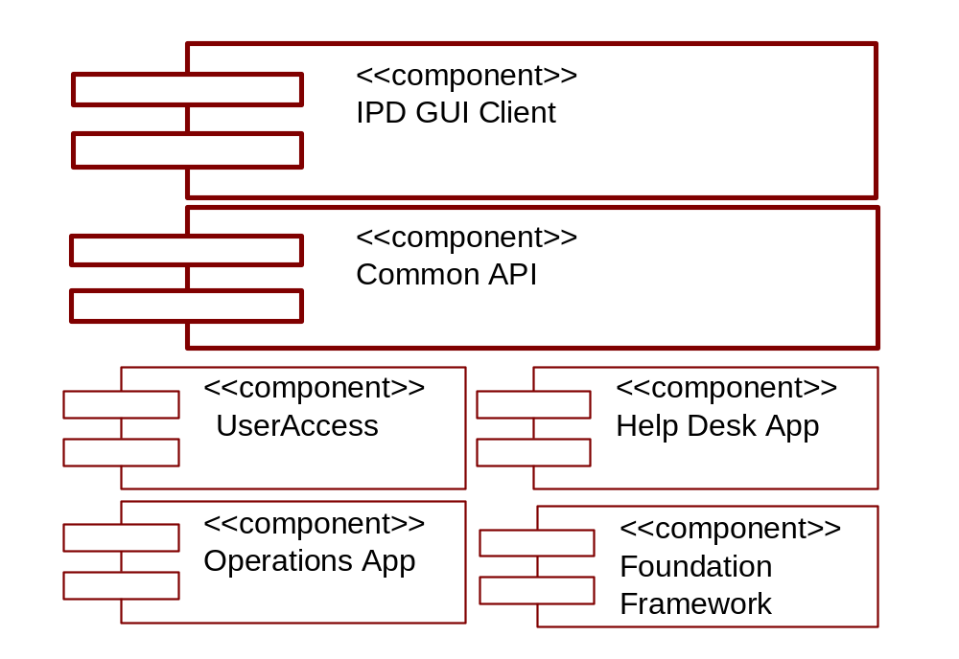

The IPD GUI Client component provides the interaction mechanism between the Operator/Help Desk/Product Maintenance Workstation process(es) and the IPD system. The workstation is comprised of two parts: a GUI, and a Client Application Server (CAS). The two components are defined as CORBA objects, and as such, can be executed in a single process or multiple processes. In the two process model, the CAS is started first, and publishes an Interoperable Object Reference (IOR) for the IPD UserAccess object in a location that the GUI can access. (Note: the CAS currently incorporates a web server that provides the IOR via an HTTP request). When the GUI process starts, it obtains the IOR for the UserAccess object, and opens a GUI screen prompts the user for logon information. The entered information passes through the Common API component to the UserAccess component. Upon validating the authentication and authorization, the CAS returns a reference to the UserSessionManager object (i.e. Help Desk App), and starts

- receiving and processing Help Desk, Operations and CFB commands through the IPD GUI component
- monitoring and processing events from the Event Infrastructure

The Operator/Help Desk Workstation process(es) contains all the administration and operation views of the data. The views of the data are retrieved when needed and cached locally for performance (most of the data for this view are read-only for the day). There is no need for transaction management in this process.

TPF Adapter Server

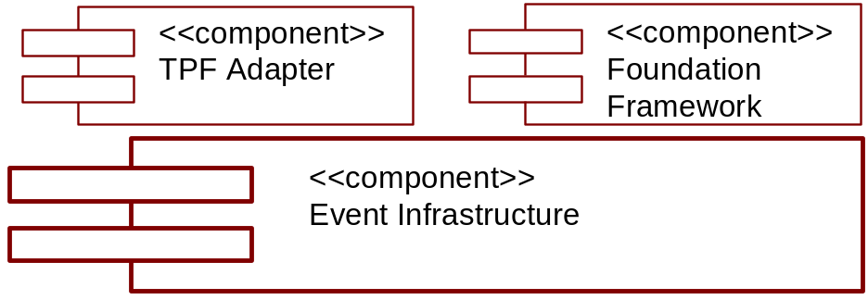

The TPF Adapter Server process starts when a system administrator manually brings up the server or it is started by a monitoring process. When started by a monitoring process, the process relies on the Foundation Framework to set up the threading policy, to establish connection with the Infrastructure Services, and to set up itself for system management. The process then establishes the connection between the TPF/Host Gateway and the TPF adapter. The process goes to the normal server operation mode to
- monitor and process outgoing order requests to TPF
- monitor and process wire order status events from the Event Infrastructure
The wire order data is managed at the TPF side. Order requests are processed as they come to the process. There is no transaction and recovery needed at this process.

IPD Server

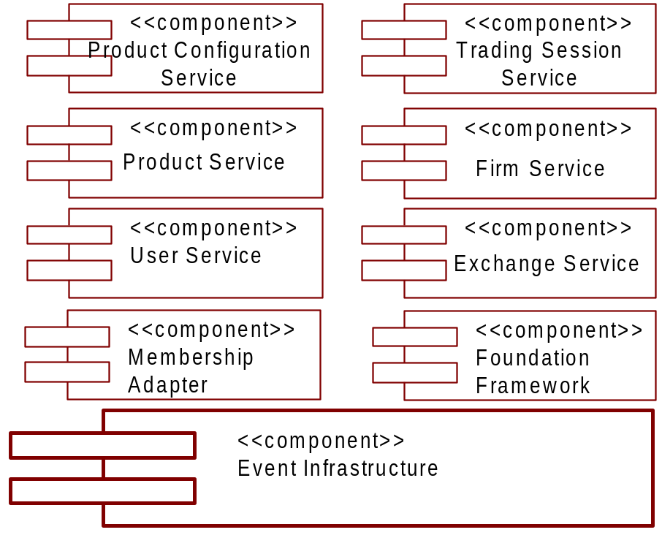

The IPD Server process starts when a system administrator manually brings up the server or it is started by a monitoring process. When started by a monitoring process, the process relies on the Foundation Framework to set up the threading policy, to establish connection with the Infrastructure Services, and to set up itself for system management. The process then initializes itself by retrieving all existing product information from the database. The process goes to the normal server operation mode to

- monitor and process Product Service and Maintenenance requests

Deployment View

Process Deployment
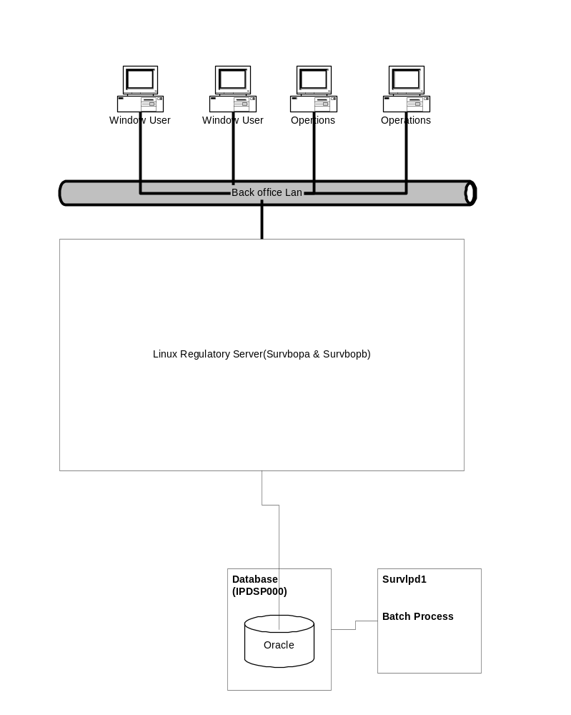

Processing Needs (Application Layer)

Hardware

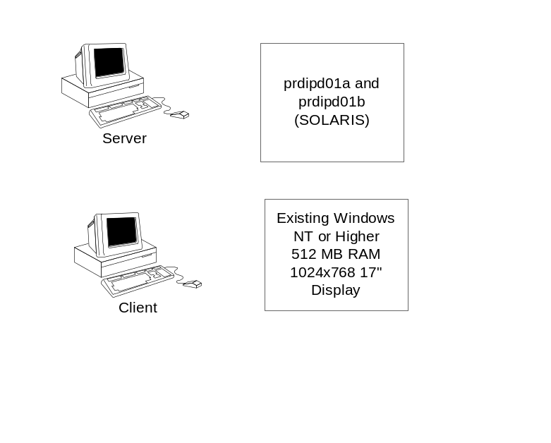

Performance

App Name application will primarily use Oracle packages and stored procedures to perform retrieval of data. Oracle provides stored procedure caching to improve performance on calls to the database.

App Name application will be implemented as a three-tier application. The user interface will be a thin client browser with the web service and business service loaded in a Linux server. The number of users using App Name application is limited at this point. The Linux server hosting the web service and business service will be capable of handling the load. App Name application is built using the Foundation framework. This provides the additional flexibility to deploy the system as N-tier if performance becomes vital.

Availability/Reliability

The App Name application will be deployed on two Linux servers(Survbopa & Survbopb) with fail over capabilities. The cold backup Linux machine will be used in the event that the primary Linux server goes down.

The Linux Server will have disk fail over and mirrored disks. If one of the disks fails, the other disk will be used as fallback.

In the event availability becomes an issue in the future, Foundation framework provides the flexibility to have master slave configurations.

Data Needs (Information Layer)

Physical Location

The data required for the App Name application will be stored in one database.

- Survp000 (survlpd1)

Capacity

There will be new tables created and will have a retention period required by business.

Integrity

Backups of the tables used by the system are already taken care of by existent periodic backups of the oracle server. The integrity requirements of the system are addressed in the E-R diagram.

Access

Each user of the system is defined a role that they are associated with. The security of the system is handled in 4 ways.

- Menu Level Security
Menu Level Security is a client level security providing the users only those menu items that they have access to.
- Service Level Security
When a service is deployed, the rights of each method invocation are assigned to roles in the security service database. This would enable service level access only to users who have the appropriate rights.
- User Authentication
Each user is authenticated with the security service before they can invoke any of the service.
- Package level security
All the oracle tables are accessed through stored procedures. No Table rights are provided to the users. The rights to execute stored procedures are provided to oracle user IDs that are not known to the users. Only the services that access the stored procedures are aware of the oracle user ID through connection pools.

Management

Oracle 9i (Solaris 2.8) will be used for data management. The file system and Oracle 9iwill be used for Log Service messages, depending on quality of service.

Hardware Installation

None

Third-Party Products

This section identifies the third-party products required by App Name application

- Java SDK, SDK for Enterprise
- Oracle 9i
- Oracle JDBC 8.0406 Thin Driver
- Struts Tag Libraries
  - Jakarta Struts
  - Struts – Layout
  - Struts – Menu
  - Display Tag
  - Cewolf (optional for graphs)
  - Ant
  - Commons
  - JSTL
  - Log4J
- Jetty
- Linux
- Clear case
- Ecclipse or some other IDE
- SQL Station

Software Installations

[Describe the expected method of deploying the application into the operational environment. Define the media and format for deploying the system. For example, the application could be a Java JAR on a server that each client downloads and installs. Describe the state of the system before and after the software installation. Define any dependencies on hardware, third party software, or other applications.]

Maintenance

[Describe the approach for routine maintenance, such as software patches. Describe emergency maintenance procedures, such as backing out an installed version of the application to the previous version, due to some catastrophic errors in the software.]

